Name:______________ Name: ______________

The Environment & Health

You and a partner will search the internet to learn different ways in which the environment can effect our health!!!

What is noise pollution?
__________________________________________________________________________________________________________________________________________________________________________________________________________________________________________________________________________________________________________________________________________

What is light pollution?
__________________________________________________________________________________________________________________________________________________________________________________________________________________________________________________________________________________________________________________________________________

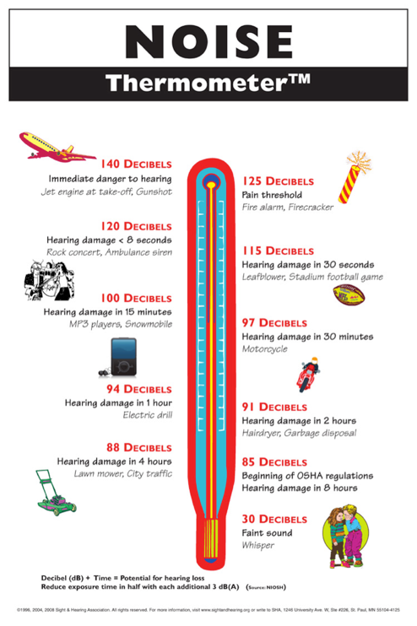

What is hypothermia?
__________________________________________________________________________________________________________________________________________________________________________________________________________________________________________________________________________________________________________________________________________

What is heat exhaustion or heat stroke?
__________________________________________________________________________________________________________________________________________________________________________________________________________________________________________________________________________________________________________________________________________

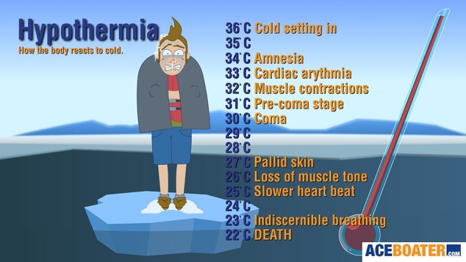

What is second hand smoke?
________________________________________________________________________________________________________________________________________________________________________________________________________________________________________________________________________

What is air pollution?
________________________________________________________________________________________________________________________________________________________________________________________________________________________________________________________________________

